PROJECT: SMART WATER FOUNTAIN

PHASE- 5 :

PROJECT OBJECTIVES:

There are many benefits to using IoT in water quality monitoring. For instance, it can help save money on water treatment and pumping costs. Additionally, it can improve the efficiency of water distribution, leading to less water waste and lower energy bills. In addition, IoT can provide real-time data on water quality, allowing for more timely interventions when problems are detected. This can lead to improved public health and safety, as well as reduced environmental impacts from water contamination. Finally, deploying IoT in water quality monitoring can help build public trust in the government and utilities that manage our water resources. Some potential issues that may arise when integrating IoT technology into the water management process include:

A. Public water governance companies may be concerned about the cost of implementing and maintaining an IoT system.

B. Privacy and ownership of data: There may be concerns regarding who owns and protects the data collected by IoT sensors

C. There may be challenges in integrating the IoT system with the water governance company’s existing systems and processes.

D. Water management may be subject to regulatory challenges or concerns related to IoT technology.

Another is the communication and networking infrastructure that will be used to transmit data from the sensors to a central server or cloud service. This may include the use of wireless technologies such as WiFi, Bluetooth or cellular, as well as wired connections. The software and algorithms used to process and analyze the data collected by the sensors will be an important part of the IoT system. This may include the use of machine learning algorithms to identify trends and patterns in the data

IOT SENSOR SETUP:

*Step 1: Set Up Your Raspberry Pi*

1. Install Raspbian OS on the microSD card and boot up your Raspberry Pi.

2. Connect the Raspberry Pi to your local Wi-Fi network using the built-in Wi-Fi or a USB Wi-Fi dongle.

3. Update and upgrade your system:

bash

sudo apt-get update

sudo apt-get upgrade

*Step 2: Assemble the Hardware*

1. Connect the water pump to the relay module. The relay module will be used to control the pump.

2. Connect the ultrasonic distance sensor to the Raspberry Pi using GPIO pins. Typically, you would connect the sensor's trigger pin to a GPIO output pin and the echo pin to a GPIO input pin.

3. Set up the water reservoir and fountain tubing. Make sure the water pump is submerged in the reservoir, and the nozzle is positioned where you want the water to flow.

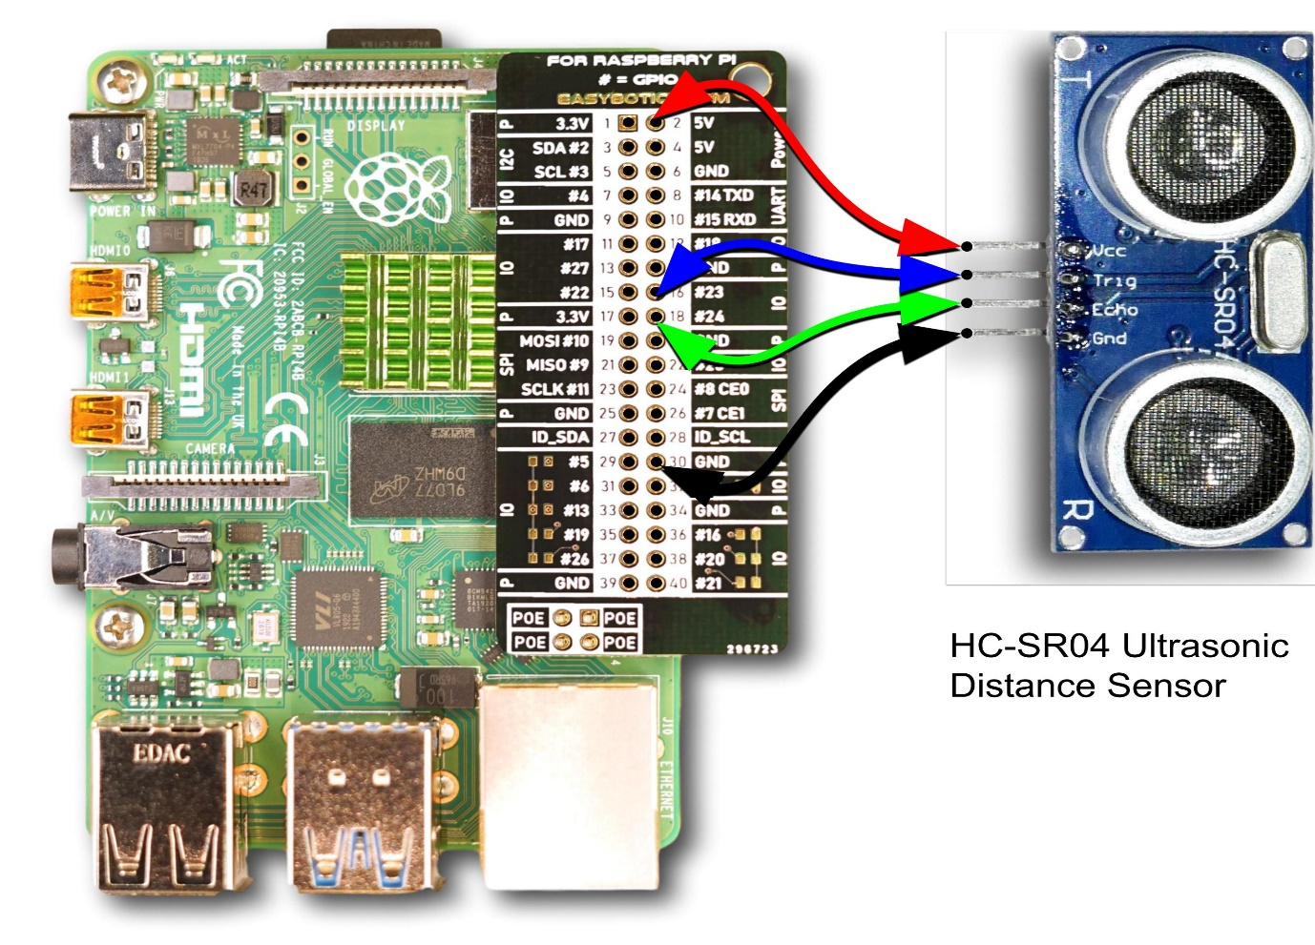

Mobile App Development:

Developing a mobile app for a smart water fountain can enhance user experience and provide advanced features for controlling and customizing the fountain's operation. Below is a step-by-step guide on how to develop a mobile app for a smart water fountain:

*1. Define the App's Purpose and Features:*

- Clearly define the objectives of your app. What functions should it offer? Common features for a smart water fountain app may include:

- Control water flow and intensity.

- Set timers and schedules for fountain operation.

- Change lighting and color options (if the fountain has these features).

- Monitor the water fountain's status, such as water levels or filter status.

- Receive maintenance alerts and reminders.

*2. Choose the Platform:*

- Decide whether you want to develop the app for Android, iOS, or both (cross-platform development).

*3. Design the User Interface (UI):*

- Design an intuitive and user-friendly interface. Consider the following design elements:

- Buttons and sliders for controlling water flow, lighting, and schedules.

- Real-time monitoring of the fountain's status.

- Notifications and alerts for maintenance and issues.

- Use wireframes and mockups to plan the app's layout and design.

*4. Development:*

- Choose the appropriate development tools and frameworks for your target platform (e.g., Android Studio for Android or Xcode for iOS).

- Develop the app, including both the front-end and back-end components.

- Integrate with the smart water fountain's hardware using IoT communication protocols, such as Bluetooth, Wi-Fi, or cellular connectivity.

*5. Connectivity:*

- Ensure that the app can establish a reliable connection with the smart water fountain. Implement secure communication protocols to prevent unauthorized access.

*6. Testing:*

- Thoroughly test the app's functionality, including the ability to control the water fountain, set schedules, and receive alerts.

- Check for compatibility with different devices and operating system versions.

*7. Integration with Cloud Services (Optional):*

- If you want to store and analyze data from the smart water fountain, consider integrating with cloud services like AWS or Azure.

*8. Security and Privacy:*

- Implement security measures to protect user data and secure communications between the app and the water fountain.

- Comply with data protection regulations, if applicable.

*9. User Authentication:*

- Implement user authentication to ensure that only authorized users can control the water fountain.

*10. Notification System:*

- Set up a notification system to alert users about maintenance needs, filter replacements, or other important updates.

*11. Testing and QA:*

- Conduct rigorous testing, including real-world testing with the smart water fountain to ensure all features work as expected.

*12. Launch the App:*

- Release the app on Google Play Store and Apple App Store.

- Promote the app through marketing channels and social media.

13. Maintenance and Updates:*

- Regularly update the app to fix bugs, improve performance, and maintain compatibility with the latest operating systems.

- Listen to user feedback and consider adding new features based on their suggestions.

*14. Documentation:*

- Document the app's architecture, functions, and any APIs for reference and future development.

Developing a mobile app for a smart water fountain can enhance user control and interaction with the fountain, making it more convenient and enjoyable. Make sure to prioritize user-friendly design, functionality, and ongoing maintenance to provide a satisfying user experience.

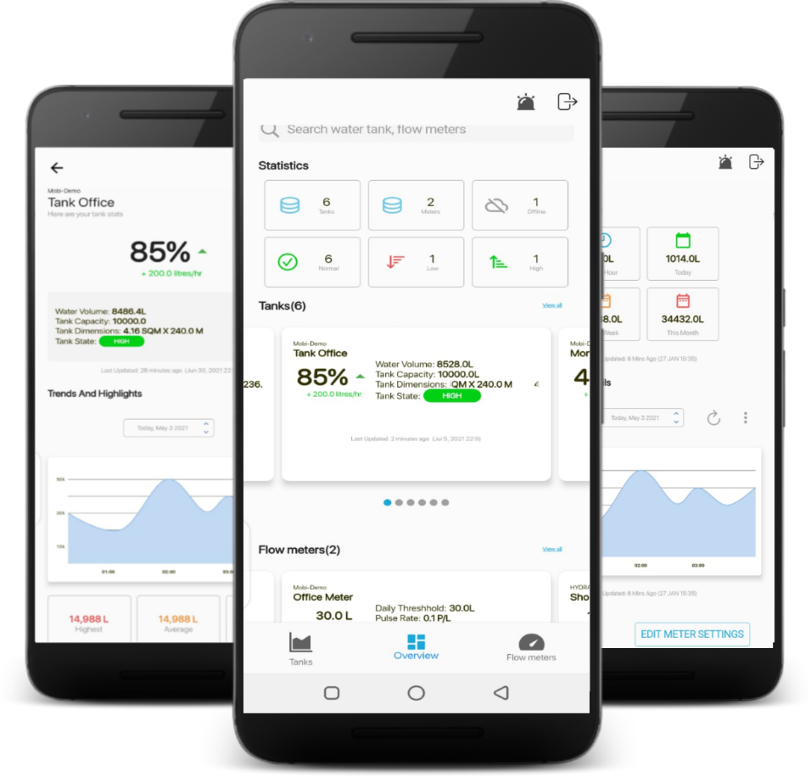

Raspberry Pi Integration:

Integrating a Raspberry Pi into a smart water fountain can add a wealth of features and capabilities, allowing for more sophisticated control, automation, and monitoring. Here's a step-by-step guide on how to integrate a Raspberry Pi into a smart water fountain:

*1. Define the Objectives:*

- Clearly outline the goals and features you want to achieve with the Raspberry Pi integration. Some common objectives for a smart water fountain might include:

- Remote control of fountain operations.

- Scheduling and automation of fountain actions.

- Monitoring and reporting of fountain status, water levels, and maintenance needs.

*2. Select the Raspberry Pi Model:*

- Choose a Raspberry Pi model that suits your project requirements. Consider factors like processing power, connectivity options, and available GPIO pins.

*3. Hardware Components:*

- Gather the necessary hardware components, including sensors (for monitoring water levels, temperature, etc.), pumps, valves, and any additional peripherals required for your specific fountain.

*4. Raspberry Pi Setup:*

- Set up the Raspberry Pi by installing the operating system (e.g., Raspberry Pi OS) and configuring network connectivity.

- Ensure your Raspberry Pi is connected to the same Wi-Fi network as the devices you want to control the fountain from.

*5. Software Development:*

- Develop the software that will run on the Raspberry Pi. This software should include the following:

- Code to interface with sensors and control fountain components (pumps, lights, etc.).

- Implement logic for scheduling and automation of fountain actions.

- Establish secure communication protocols for remote control and monitoring.

*6. Data Storage and Management (Optional):*

- Consider setting up a database or cloud service for storing data from the fountain's sensors and logs. This can be useful for historical analysis and monitoring trends.

*7. Web Interface or Mobile App (Optional):*

- You can create a web interface or a mobile app to control and monitor the fountain remotely. This will require web development skills to build a user-friendly interface.

*8. Security and Privacy:*

- Implement security measures to protect your Raspberry Pi and the data it collects. Secure remote access and communication to prevent unauthorized control.

*9. Testing:*

- Thoroughly test the Raspberry Pi software and hardware components to ensure they function correctly. Verify that sensors are providing accurate data, and that control actions (e.g., turning the fountain on and off) work as expected.

*10. Power Management:*

- Plan for power management, especially if the Raspberry Pi is not near a power source. Consider using a UPS (Uninterruptible Power Supply) or solar power options for remote installations.

*11. Enclosure:*

- Place the Raspberry Pi and associated electronics in a suitable enclosure to protect them from environmental factors.

*12. Mounting and Plumbing:*

- Install sensors, pumps, valves, and any other hardware components within the water fountain according to your design.

*13. User Interface:*

- If you're creating a web interface or mobile app, design and develop a user-friendly interface for controlling and monitoring the smart water fountain.

*14. Documentation:*

- Document the system architecture, software, and any custom APIs for reference and future development.

*15. Maintenance and Updates:*

- Regularly maintain and update both the hardware and software to ensure reliable operation and compatibility with new operating system versions or components.

*16. Launch and Promote:*

- Once you've thoroughly tested and refined your smart water fountain, you can launch it and promote it to users or customers who can benefit from its features.

Integrating a Raspberry Pi into a smart water fountain can enhance its functionality and make it more controllable and intelligent. It's important to plan and execute the integration carefully to ensure reliable operation and user satisfaction.

Code Implementation:

import requests

# Define the Raspberry Pi's IP address

raspberry_pi_ip = 'your_pi_ip_address'

# Start the water fountain

response = requests.post(f'http://{raspberry_pi_ip}:5000/start')

if response.status_code == 200:

print('Fountain started')

# Stop the water fountain

response = requests.post(f'http://{raspberry_pi_ip}:5000/stop')

if response.status_code == 200:

print('Fountain stopped')

# Get water level

response = requests.get(f'http://{raspberry_pi_ip}:5000/water-level')

if resonse.status_code == 200:

water_level = response.json()['water_level']

print(f'Water level: {water_level}’)

WEB DEVELOPMENT TECHNOLOGIES USING JAVASCRIPT CODE:

<html>

<head>

<title>Smart Water Fountain</title>

<style>

/* CSS for styling the fountain (same as before) */

/* ... */

.water-flow.stopped {

animation-play-state: paused;

}

</style>

</head>

<body>

<h1>Smart Water Fountain</h1>

<div class="fountain">

<div class="water-flow"></div>

</div>

<button id="startButton">Start Fountain</button>

<button id="stopButton">Stop Fountain</button>

<input type="range" id="flowRate" min="1" max="10" value="5">

<p>Flow Rate: <span id="flowRateValue">5</span></p>

<script>

const waterFlow = document.querySelector(".water-flow");

const startButton = document.getElementById("startButton");

const stopButton = document.getElementById("stopButton");

const flowRateSlider = document.getElementById("flowRate");

const flowRateValue = document.getElementById("flowRateValue");

let currentFlowRate = 5; // Default flow rate

startButton.addEventListener("click", () => {

waterFlow.style.animationPlayState = "running";

});

stopButton.addEventListener("click", () => {

waterFlow.style.animationPlayState = "paused";

});

flowRateSlider.addEventListener("input", () => {

currentFlowRate = flowRateSlider.value;

flowRateValue.textContent = currentFlowRate;

const animationDuration = 10 / currentFlowRate; // Inverse of flow rate

waterFlow.style.animationDuration = ${animationDuration}s;

});

</script>

</body>

</html>

OUTPUT :

The coding is in the language of java script

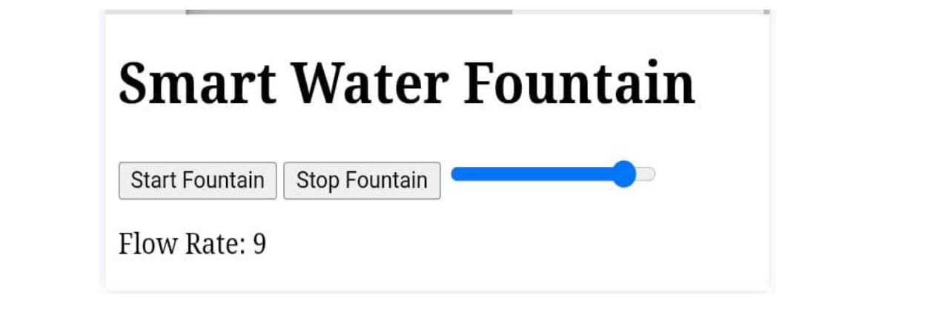

Benefits of smart water fountain status system:

A real-time water fountain status system can promote water efficiency and public awareness in several ways:

*1. Water Conservation:*

- *Smart Water Usage:* The system can monitor water fountains' water levels and flow rates in real-time. It allows for precise control, enabling the fountains to operate only when needed. This reduces unnecessary water wastage, contributing to water conservation.

- *Timed Operation:* Smart scheduling ensures that fountains run only during specific hours or periods of high foot traffic, preventing water usage during less busy times.

- *Remote Control:* Maintenance personnel can remotely turn off fountains during maintenance or repair, preventing water waste while addressing issues.

*2. Data-Driven Insights:*

- *Monitoring and Reporting:* Real-time data collected by the system can be used to generate reports and analytics on water consumption. These insights help authorities and facility managers identify trends, outliers, and potential areas for improvement.

- *Leak Detection:* The system can detect abnormal water consumption patterns that may indicate leaks or malfunctions, allowing for prompt repairs.

*3. Public Awareness:*

- *Real-time Availability Information:* The system can provide the public with real-time information on the availability of water fountains. Users can check whether a fountain is operational before visiting, reducing wasted trips and the need to buy bottled water.

- *Promoting Hydration:* By making it easy for people to find working water fountains, the system encourages the use of tap water, promoting hydration and reducing the reliance on single-use plastic bottles.

- *Educational Opportunities:* Real-time data can be used for educational purposes. For example, the system can display information about water conservation, the environmental impact of bottled water, or the quality of tap water. This educates the public about water-related issues.

*4. Customized User Experiences:*

- *Mobile Apps:* If the system integrates with a mobile app, users can receive notifications and alerts about the status and availability of nearby water fountains. This personalized experience encourages efficient use of resources.

- *User Feedback:* Users can provide feedback on fountain availability and quality through the app, which can help improve the maintenance and operation of the fountains.

*5. Water Quality and Safety:*

- *Water Quality Monitoring:* The system can also monitor water quality, ensuring that the fountain's water is safe to drink. If water quality parameters deviate from standards, the system can issue alerts and shut down the fountain.

- *Safety Alerts:* In case of contamination, the system can quickly disable the fountain to prevent the public from drinking unsafe water.

*6. Resource Allocation:*

- *Resource Optimization:* Authorities can allocate resources more effectively based on real-time usage data. If certain fountains are consistently underused, adjustments can be made to better allocate resources to more heavily used areas.

*7. Eco-Friendly Practices:*

- *Promotion of Sustainable Practices:* By making water fountains more efficient and accessible, the system encourages eco-friendly behavior and aligns with sustainability goals.

Overall, a real-time water fountain status system not only conserves water but also educates the public and encourages more sustainable practices. By promoting awareness and efficient water usage, such a system can have a positive impact on water resources and the environment.